

Sec: SR.IIT_*CO-SC(MODEL-A&B) Date: 18-09-22
Time: 3HRS Max. Marks: 180
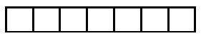
Name of the Student: ___________________ H.T. NO:

18-09-22_SR.STAR CO-SUPERCHAINA(MODEL-A&B)_JEE-ADV_PTA-1_SYLLABUS
PHYSICS: Kinematics :Kinematics in one and two dimensions (Cartesian coordinates only), projectiles, Relative velocity.
NLM: Newton’s laws of motion; Inertial and uniformly accelerated frames of reference;
CHEMISTRY: Detection of elements: (N, S, halogens) and their estimation.
Structure: Hybridisation of carbon; σ and π-bonds; Shapes of simple organic molecules;
IUPAC nomenclature of organic molecules (hydrocarbons, including simple cyclic hydrocarbons and their mono-functional and bi-functional derivatives only);
Isomerism: Structural(Excluding Tautomerism) and geometrical isomerism; Stereoisomers and stereochemical relationship (enantiomers, diastereomers, meso) of compounds containing only up to two asymmetric centres (R,S and E,Z configurations excluded);

MATHEMATICS: Functions : Real Valued Functions Of A Real Variable, Into, Onto And One-To-One Functions, Absolute Value, Polynomial, Rational, Trigonometric, Exponential And Logarithmic Functions,
Even And Odd Functions, Sum, Difference, Product And Quotient Of Two Functions, Composite Functions, Inverse Of A Function
LIMITS

Time: 3:00Hour’s Important instructions Max Marks: 180
PHYSICS:
Section | Question Type | +Ve  Marks | - Ve  Marks | No.of Qs | Total marks
Sec – I(Q.N : 1 – 6) | Questions with Multiple Correct Choice  (partial marking scheme) (+1,0) | +4 | -2 | 6 | 24
Sec – II(Q.N : 7 – 14) | Questions with Numerical Value Type  (e.g. 6.25, 7.00, ‐0.33, ‐.30, 30.27, ‐127.30) | +3 | 0 | 8 | 24
Sec – III(Q.N : 15-18) | Questions with Comprehension Type  (2 Comprehensions – 2 +2 = 4Q) | +3 | -1 | 4 | 12
Total |  |  |  | 18 | 60

CHEMISTRY:
Section | Question Type | +Ve  Marks | - Ve  Marks | No.of Qs | Total marks
Sec – I(Q.N :19 – 24) | Questions with Multiple Correct Choice  (partial marking scheme) (+1,0) | +4 | -2 | 6 | 24
Sec – II(Q.N : 25 –32) | Questions with Numerical Value Type  (e.g. 6.25, 7.00, ‐0.33, ‐.30, 30.27, ‐127.30) | +3 | 0 | 8 | 24
Sec – III(Q.N : 33-36) | Questions with Comprehension Type  (2 Comprehensions – 2 +2 = 4Q) | +3 | -1 | 4 | 12
Total |  |  |  | 18 | 60

Mathematics:
Section | Question Type | +Ve  Marks | - Ve  Marks | No.of Qs | Total marks
Sec – I(Q.N:37 – 42) | Questions with Multiple Correct Choice  (partial marking scheme) (+1,0) | +4 | -2 | 6 | 24
Sec – II(Q.N :43–50) | Questions with Numerical Value Type  (e.g. 6.25, 7.00, ‐0.33, ‐.30, 30.27, ‐127.30) | +3 | 0 | 8 | 24
Sec –III(Q.N : 51-54) | Questions with Comprehension Type  (2 Comprehensions – 2 +2 = 4Q) | +3 | -1 | 4 | 12
Total |  |  |  | 18 | 60
PHYSICS MAX.MARKS: 60
SECTION- I
(Maximum Marks : 24)
This section contains SIX (06) questions.
Each question has FOUR options for correct answer(s). ONE OR MORE THAN ONE of these four option(s) is (are) correct option(s).
For each question, choose the correct option(s) to answer the question.
Answer to each question will be evaluated according to the following marking scheme:
Full Marks : +4 If only (all) the correct option(s) is (are) chosen.
Partial Marks: +3 If all the four options are correct but ONLY three options are chosen.
Partial Marks: +2 If three or more options are correct but ONLY two options are chosen, both of which are correct options.
Partial Marks : +1 If two or more options are correct but ONLY one option is chosen and it is a correct option.
Zero Marks : 0 If none of the options is chosen (i.e. the question is unanswered).
Negative Marks: -2 In all other cases.
1. Two projectile are thrown at the same time from two different points. The projectile thrown from the origin has initial velocity 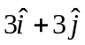 with respect to earth. The projectile has initial velocity 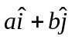 with respect to earth thrown from the point (10, 5). ( is a unit vector along horizontal, along vertical). If the projectile collides after two second, then the
A) value of is  B) value of is 
C) value of b is D) value of b is
2. In the figure shown all the surfaces are smooth. All the blocks A, B and C are movable. x-y plane is vertical plane as shown in the figure. The system is released from rest at the shown instant. Then choose the correct option(s).
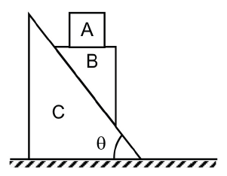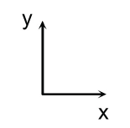
A) Acceleration of block A relative to ground is along negative y-direction.
B) Acceleration of block A relative to block B is along negative x-direction.
C) Acceleration of block B with respect to ground is 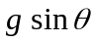 along the incline direction.
D) Acceleration of block B and block C along horizontal must be equal in magnitude if their masses are equal.

3. A ball of mass m is projected from a level ground with a velocity u making an angle with the horizontal. There is a horizontal wind blowing in the direction of motion of the ball. Due to wind the ball experiences a constant horizontal force of 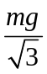 in the direction of its motion. Then choose the correct option(s).
A) Trajectory of the ball with respect to ground will not be parabolic.
B) For horizontal range of the ball to be maximum 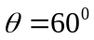.
C) For horizontal range of the ball to be maximum 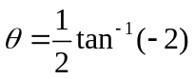
D) Maximum possible horizontal range 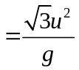.
4. A particle is moving along a straight line in such a way that its velocity versus time graph is a parabola (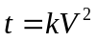, t is time, k is constant, V is velocity) as shown in the figure. Choose the correct option(s)
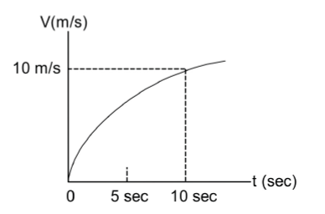
A) acceleration of the particle is 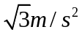 throughout the journey
B) average acceleration of particle is 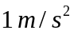 for the interval of first 5 sec
C) average acceleration of particle is less than 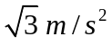 for the interval of first 5 sec
D) average acceleration of particle is less than for the interval of 5 sec to 10 sec
5. The system shown is in equilibrium. All the strings and pulleys are massless. Which of the following statement(s) is/ are true immediately after the string above block B is cut?
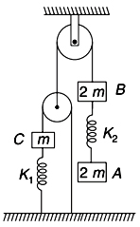
A) magnitude of Rate of change of velocity of B relative to A is 2g
B) magnitude of Rate of change of velocity of B relative to C is 0
C) magnitude of Rate of change of velocity of C relative to A is 2g
D) Tension in spring of force constant 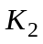 will be higher than tension in the other spring with force constant K₁.
6. A particle is in motion such that its velocity parallel to y-axis is constant and parallel to x-axis it is proportional to y coordinate.
A) The particle moves with constant acceleration
B) The path of the particle is a hyperbola
C) If the particle starts from the origin, it will initially move in y direction
D) If the particle starts from the origin, it will initially move in x direction
SECTION - II
(Maximum Marks : 24)
This section contains EIGHT (08) questions. The answer to each question is a NUMERICAL VALUE
For each question, enter the correct numerical value (in decimal notation, truncated/rounded off to the second decimal place; e.g. 6.25, 7.00, -0.33, -.30, 30.27, -127.30) designated to enter the answer.
Answer to each question will be evaluated according to the following marking scheme:
Full Marks: +3 If ONLY the correct numerical value is entered as answer.
Zero Marks: 0 In all other cases.
7. A ball is projected from a point 10m away from a large wall. If the initial velocity with which the ball can be projected is 15 m/s, then in order to hit the wall at the highest possible point, if the angle with the horizontal that it must be projected is , then the value of 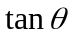 is …………
8. Assuming all parts of the string to be vertical and pulleys 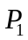 and 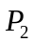 to be massless and frictionless. Find the acceleration (in 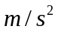) of point A of the string. Assuming string to be massless and inextensible. (Take 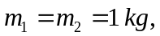 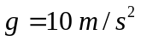)
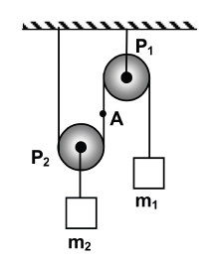
9. A car starts from rest from origin along x-axis with an acceleration (a) given by the relation 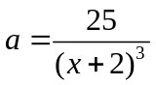, where is in and is in metre. The maximum velocity of the car will be ( is the position of the car) [in 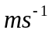 is]
10. A particle of mass 0.5 kg is projected horizontally in air with initial velocity of 9 m/s. During the motion of the particle in air a constant air drag of magnitude 5N acts on it opposite to its instantaneous direction of motion. Find its speed (in m/s) when its direction of motion makes an angle of 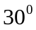 with the horizontal. (given )
11. A particle is projected with speed u from ground at an angle with the horizontal such that the area under the trajectory is maximum. The value of is (in degree)
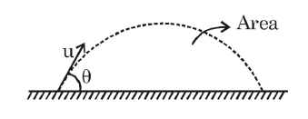
12. An inclined plane is located at angle 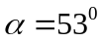 to the horizontal. There is a hole at point B in inclined plane as shown in the figure. A particle is projected along the plane with speed  at an angle 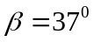 to the horizontal in such a way so that it get into the hole. Neglect any type of friction. Find the speed (in m/s), if 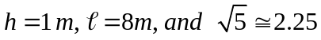.
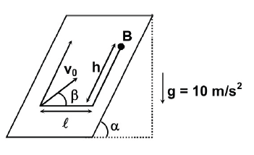
13. A body is projected vertically upwards with a velocity u = 5 m/s. After time t another body is projected vertically upward from the same point with a velocity v = 3 m/s. If they meet in minimum time duration measured from the projection of first body, then the time t is ……… ()
14. In the arrangement shown, each of the three springs 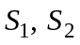, and 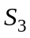 has a force constant ‘k’. Strings and pulleys are massless. A force is gradually increased to pull down pulley 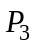 through a distance ‘x’. the final value of applied force F in multiples of 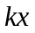 is________
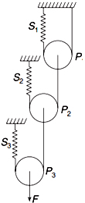
Section – III
(COMPREHENSIN TYPE)
This section contains 2Paragraphs. Based on each paragraph, there are 2 questions. Each question has 4 options (A), (B), (C) and (D) for its answer, out of which ONLY ONE option can be correct.
Marking scheme: +3 for correct answer, 0 if not attempted and -1 in all other cases

Paragraph for Question Nos. 15 to 16:
In the figure shown 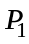 and 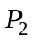 are massless pulleys. is fixed and can move. Masses of A, B and C are 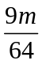, 2m and m respectively. All contacts are smooth and the string is massless 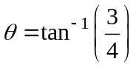. (Take 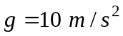).
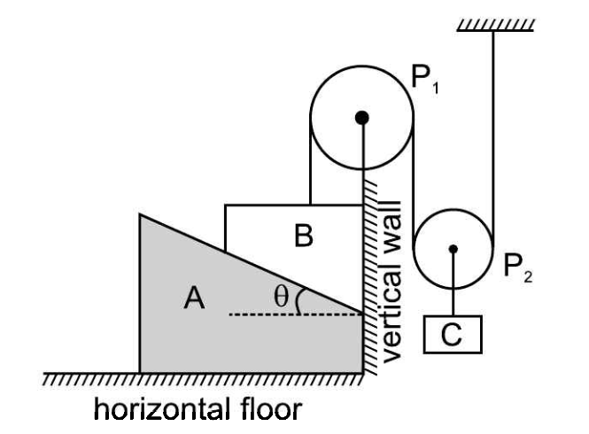
15. The ratio of magnitude of accelerations of blocks A and C
A)  B)  C) 2 D)
16. Magnitude of acceleration of block C is
A) 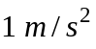 B) 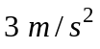 C) 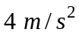 D) 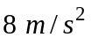

Paragraph for Question Nos. 17 to 18:
A projectile of mass m is fired into a liquid at an angle 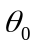 with horizontal and initial speed 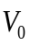 as shown. If the liquid develops a drag force (resistance force) on the projectile which is proportional to its instantaneous velocity v i.e. 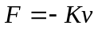 where K is a positive constant of appropriate dimensions. Assume that the projectile moves in liquid only.
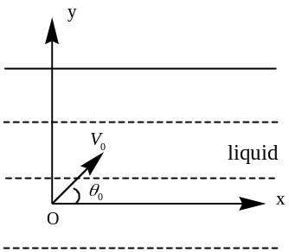
17. Vertical (Y- component) component of velocity of projectile as a function of time is
A) 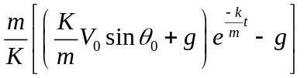 B) 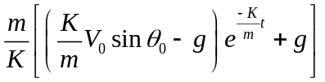
C) 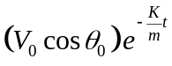 D) 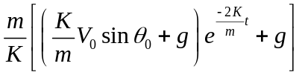
18. Maximum value of x co-ordinate is
A) 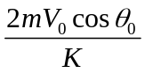 B) 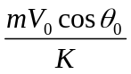 C) 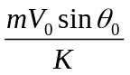 D) 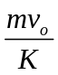
CHEMISTRY MAX.MARKS: 60
SECTION- I
(Maximum Marks : 24)
This section contains SIX (06) questions.
Each question has FOUR options for correct answer(s). ONE OR MORE THAN ONE of these four option(s) is (are) correct option(s).
For each question, choose the correct option(s) to answer the question.
Answer to each question will be evaluated according to the following marking scheme:
Full Marks : +4 If only (all) the correct option(s) is (are) chosen.
Partial Marks: +3 If all the four options are correct but ONLY three options are chosen.
Partial Marks: +2 If three or more options are correct but ONLY two options are chosen, both of which are correct options.
Partial Marks : +1 If two or more options are correct but ONLY one option is chosen and it is a correct option.
Zero Marks : 0 If none of the options is chosen (i.e. the question is unanswered).
Negative Marks: -2 In all other cases.
19. Which among the following can exhibit GI (Geometrical Isomerism)?
A) 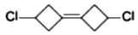 B) 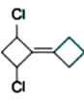
C) 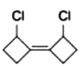 D) 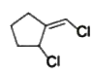
20. Correct statements concerning various conformers of 2-fluoroethanol is/are
A) Anti-conformer is the most stable conformer
B) There is intramolecular H-bonding in its most stable conformer.
C) The most stable conformer has greater steric strain than 2nd most stable conformer.
D) Dissolving in water lower the percentage of most stable conformer.
21. One of the most common antibiotics is penicillin G, which has the structure as shown below :
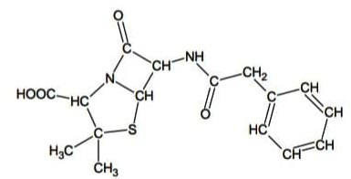
Identify the correct statement regarding penicillin G
A) It has 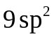 hybridized carbons
B) It has 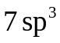 carbons
C) It contains amino groups as functional groups
D) It has total 12 lone pairs
22. Which of the following is/are correct?
A) 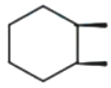 is optically inactive due to plane of symmetry present in the molecule
B) 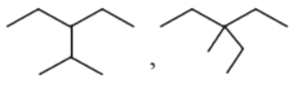 are chain isomers
C)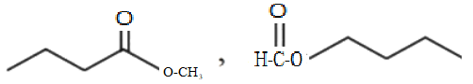 are metamers
D) Mesotartaric acid has non zero dipole moment.
23. Which of the following pairs are NOT enantiomers?
i) 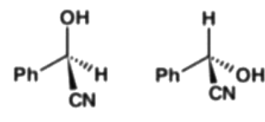 ii) 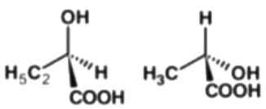
iii) 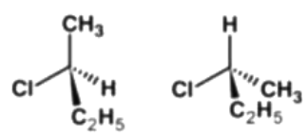 iv) 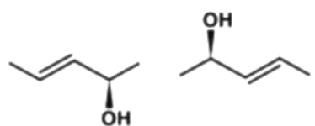
A) I B) II C) III D) IV
24. For the given structures, find the optically active structures :
A) 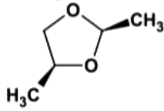 B) 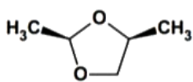
C) 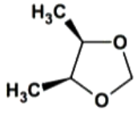 D) 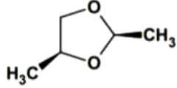
SECTION - II
(Maximum Marks : 24)
This section contains EIGHT (08) questions. The answer to each question is a NUMERICAL VALUE
For each question, enter the correct numerical value (in decimal notation, truncated/rounded off to the second decimal place; e.g. 6.25, 7.00, -0.33, -.30, 30.27, -127.30) designated to enter the answer.
Answer to each question will be evaluated according to the following marking scheme:
Full Marks: +3 If ONLY the correct numerical value is entered as answer.
Zero Marks: 0 In all other cases.
25. The total number(s) of stable conformers with non-zero dipole moment for the following is/are
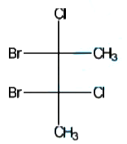
26. How many total number of structural isomers of 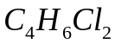 are possible having cyclic structures?
27. Find the total number of optical active isomers for the given compound.
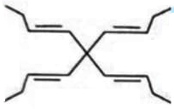
28. Number of meso isomers of the given compound is
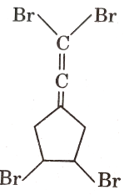

29. For the given compound [X], the total number of optical active stereoisomers are
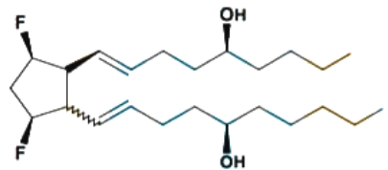
This type of bond indicate that the configuration at the specific carbon and the geometry of the double bond is fixed.
This type of bond indicate that the configuration at the specific carbon and the geometry of the double bond is not fixed.
30. Number of geometrical isomers possible for the compound [X]
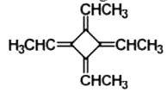
31. In how many of the following molecules ALL ATOMS are coplanar?
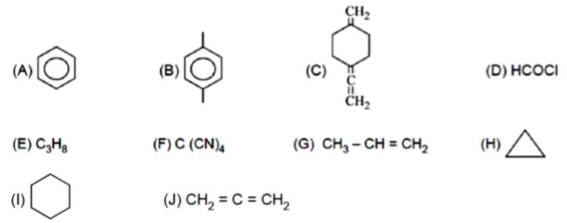
32. What is the locant of 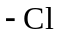 in IUPAC name of the given compound?
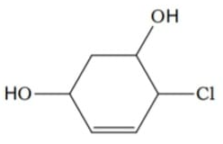

Section – III
(COMPREHENSIN TYPE)
This section contains 2Paragraphs. Based on each paragraph, there are 2 questions. Each question has 4 options (A), (B), (C) and (D) for its answer, out of which ONLY ONE option can be correct.
Marking scheme: +3 for correct answer, 0 if not attempted and -1 in all other cases

Paragraph for Question Nos. 33 to 34:
The diuretic cyclothiazide is used as a mixture of stereoisomers. It is capable of reducting or essentially eliminating rapid desensitization of the former receptor. It’s structure is given below.
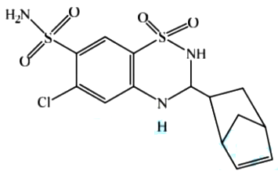
33. Find the total number of chiral carbons present in the given molecule.
A) 3 B) 4 C) 5 D) 6
34. How many stereoisomers can exist for the given compound (Cyclothiazide)
A) 2 B) 4 C) 8 D) 16
Paragraph for Question Nos. 35 to 36:
24 gm of optically pure tartaric acid is dissolved in water to make 240 ml solution. It is
kept in 20 cm polarimeter tube and plane polarised light is passed through it to produce
rotation of 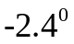.
35. If mixture of 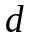 and tartaric acid has the specific rotation 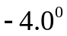, calculate the %
of optical purity of this mixture?
A) 50 % B) 66.67 % C) 33.33 % D) None of these
36. Calculate the % of tartaric acid in a mixture of and tartaric acid which
has the observed specific rotation 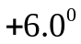.
A) 25 % B) 75 % C) 50 % D) 66.67 %
MATHEMATICS MAX.MARKS: 60
SECTION- I
(Maximum Marks : 24)
This section contains SIX (06) questions.
Each question has FOUR options for correct answer(s). ONE OR MORE THAN ONE of these four option(s) is (are) correct option(s).
For each question, choose the correct option(s) to answer the question.
Answer to each question will be evaluated according to the following marking scheme:
Full Marks : +4 If only (all) the correct option(s) is (are) chosen.
Partial Marks: +3 If all the four options are correct but ONLY three options are chosen.
Partial Marks: +2 If three or more options are correct but ONLY two options are chosen, both of which are correct options.
Partial Marks : +1 If two or more options are correct but ONLY one option is chosen and it is a correct option.
Zero Marks : 0 If none of the options is chosen (i.e. the question is unanswered).
Negative Marks: -2 In all other cases.
37. Let 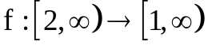 defined by 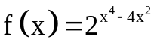 and 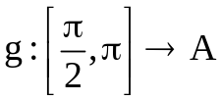 defined by 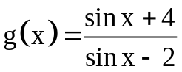 be two invertible functions, then which of the following option(s) is/are correct?
A) 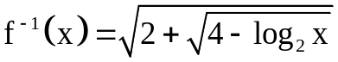 B) 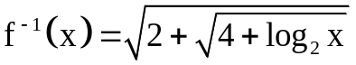
C) 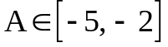 D) 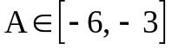
38. If 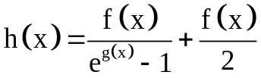 where f & g are defined from 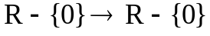then which of the following option(s) is/are correct?
A) If 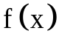 is odd and 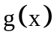 is even, then h(x) can be an even function
B) If is odd and g(x) is even, then h(x) can be an odd function
C) If is an odd function and g(x) is odd then h(x) can be an even function
D) If is an odd function and g(x) is odd then h(x) can be an odd function

39. Which of the following option(s) is/are correct?
A) 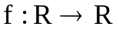 satisfies 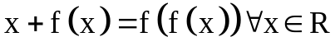 No. of solutions for 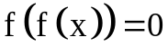is 1
B) satisfies No. of solution for is 0
C) , then 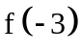 can be equal to -9
D) , then 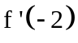 can be equal to -2
40. 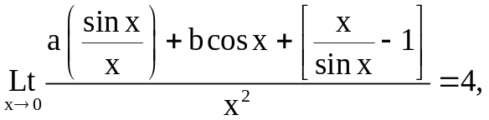 then which of the following option(s) is/are correct? ( [.] denotes G.I.F )
A) 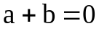 B) 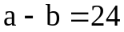
C) 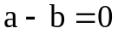 D) Given data isn't consistent
41. Which of the following option(s) is/are correct?
( [.]G.I.F, {.} Fractional part )
A) 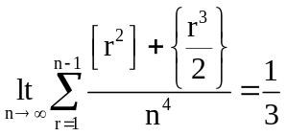 B) 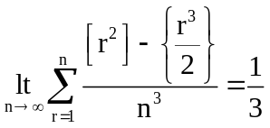
C) 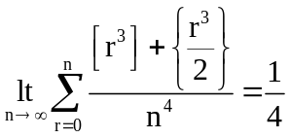 D) 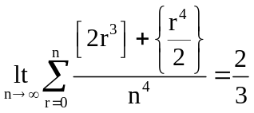
42. f : R → [–1, ∞) and f(x) = ln( [|sin2x| + |cos2x|] ) (where [⋅] is greatest integer function).
A)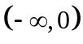 ∩ range of f(x) is null set
B) f(x) is periodic but fundamental period not defined
C) f(x) is invertible in 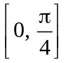
D) f(x) is into function.

SECTION - II
(Maximum Marks : 24)
This section contains EIGHT (08) questions. The answer to each question is a NUMERICAL VALUE
For each question, enter the correct numerical value (in decimal notation, truncated/rounded off to the second decimal place; e.g. 6.25, 7.00, -0.33, -.30, 30.27, -127.30) designated to enter the answer.
Answer to each question will be evaluated according to the following marking scheme:
Full Marks: +3 If ONLY the correct numerical value is entered as answer.
Zero Marks: 0 In all other cases.
43. 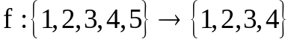 such that 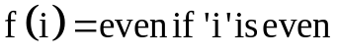 and 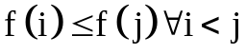. The number of such functions possible is ...............
44. 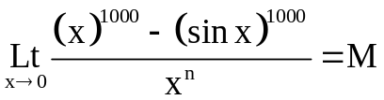 (a finite non-zero quantity ) then 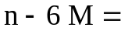.............
45. 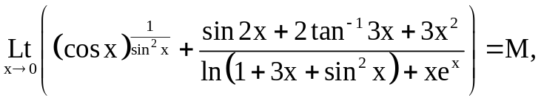 then 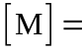
([.] denotes G.I.F ) .................
46. If 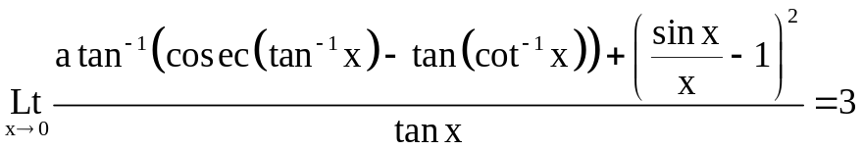
then the value of a = ................
47. 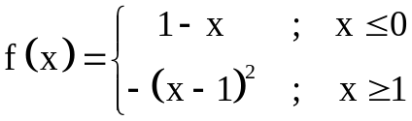. Then number of solutions of 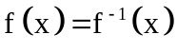 is ...............
48. If and  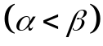 are the roots of the equation
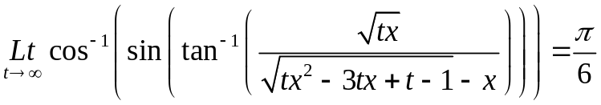 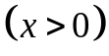 then 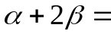_________
49. Let 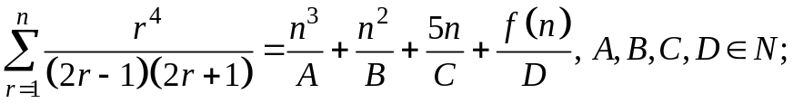 where f(n) is the ratio of two linear polynomials such that 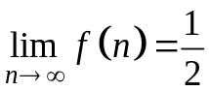. Find the value of 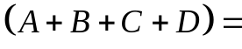.
50. Let f be an even function satisfying 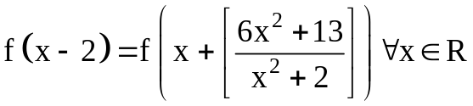 and 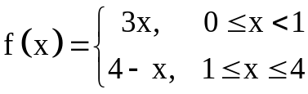 (Note : [.] denotes greatest integer function of x) then the value of 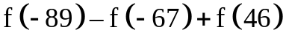is equal to
Section – III
(COMPREHENSIN TYPE)
This section contains 2Paragraphs. Based on each paragraph, there are 2 questions. Each question has 4 options (A), (B), (C) and (D) for its answer, out of which ONLY ONE option can be correct.
Marking scheme: +3 for correct answer, 0 if not attempted and -1 in all other cases

Paragraph for Question Nos. 51 to 52:
Consider the function f(x) satisfying the identity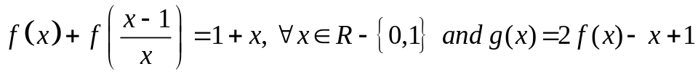
51. The range of y=g(x) is 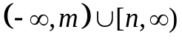then the value of m+n is equal to _______
A) 3 B) 6 C) 5 D) 4
52. The number of roots of the equation g(x) = 1 is________
A) 0 B) 2 C) 3 D) 1
Paragraph for Question Nos. 53 to 54:
For x>0 if 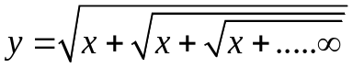 , then 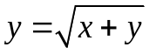and hence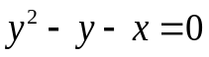 .So 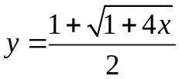 . Now evaluate the following limit values.
53. 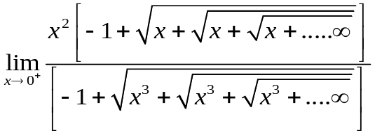 =
A) 0 B) -1 C) 1 D) 1/4
54. 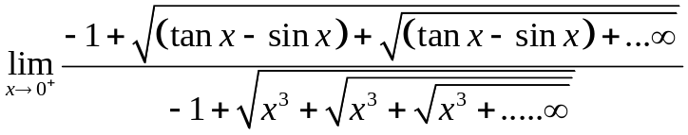
A) 0 B) 1/2 C) -1/2 D) 1

